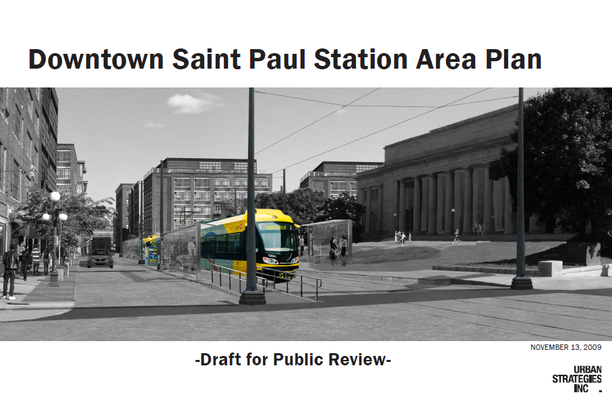
PLANNING COMMISSION PUBLIC HEARING ON
DOWNTOWN SAINT PAUL STATION AREA PLAN
DECEMBER 18, 2009

The Saint Paul Planning Commission will hold a public hearing on the Downtown Saint Paul Station Area Plan at 8:30 a.m. on Friday, December 18, 2009 in Room 40 of City Hall, 15 W. Kellogg Boulevard. All interested persons are invited to attend the hearing to present their comments on the Plan, which will be adopted by the City Council as a part of the City’s Comprehensive Plan.

The Downtown Station Area Plan focuses on city-building opportunities related to the presence of light rail transit (LRT) in downtown. The Plan represents the City’s on-going commitment to transit-supportive development by exploring opportunities in downtown to:
- enhance the public realm;
- improve options for mobility, with a strong emphasis on pedestrian movement;
- diversify land uses and increase density on key redevelopment sites; and
- realize significant market potential over the next 15 years.

The Downtown Station Area Plan covers two of the three downtown Central Corridor LRT stations: 4th/Cedar (referred to as Central) and Union Depot. Recommendations are presented in four key areas: 1) mobility; 2) land use; 3) built form; and 4) public realm. In addition, the Plan explores the development potential of key sites, and ways in which the presence of LRT will improve the street environment in downtown.

The Plan was prepared by Urban Strategies, Inc. under the direction of City of Saint Paul staff and a community-based steering committee.

The draft Plan is available on the City’s web site at www.stpaul.gov/centralcorridor, or by contacting Lucy Thompson at 651.266.6578 or lucy.thompson@ci.stpaul.mn.us . Written comments will be accepted until 4:30 p.m. on December 18, 2009 and should be sent to Ms. Thompson at the above e-mail address or c/o PED, 1300 City Hall Annex, 25. W. 4th Street, Saint Paul, MN, 55102. Any questions may also be directed to Ms. Thompson.

